LAB UNIVERSITY OF APPLIED SCIENCES
Faculty of Technology
Industrial Information Technology

Machine Learning Environment Validation
on CSC Puhti Supercomputer
Using Jupyter Notebook and scikit-learn

Laboratory Report
ML Course Spring 2026 | Project 2017391

Submitted by:
Peter Adedayo Oketade
Student, Industrial Information Technology
LAB University of Applied Sciences

Date of Submission: 13 May 2026
Supervisor: ML Course Instructor

Table of Contents
1. Introduction 3
2. Objectives 4
3. Methodology 4
3.1 Accessing the CSC Puhti Platform 4
3.2 Launching a Jupyter Interactive Session 5
3.3 Resource Allocation Settings 6
3.4 Setting Up the Python Environment 6
4. Results 7
4.1 Environment Verification 7
4.2 Machine Learning Workflow – Iris Dataset 8
4.3 Model Training and Evaluation 9
4.4 TensorFlow Module Error 11
5. Challenges and Limitations 12
6. Conclusion 13
7. References 13
List of Figures 14

1. Introduction
The rapid advancement of machine learning (ML) has created a strong demand for high-performance computing environments capable of supporting data-intensive experimentation. For academic and research purposes, access to such environments is often provided through national computing infrastructure services. In Finland, the CSC – IT Center for Science provides a national supercomputing platform called Puhti, which offers researchers, students, and academic projects access to powerful hardware resources, shared file systems, and pre-configured software environments.
This report documents the process of setting up, validating, and executing a basic machine learning workflow on the CSC Puhti supercomputer. The work was carried out as part of the ML Course Spring 2026 (Project 2017391) at LAB University of Applied Sciences, under the Industrial Information Technology programme.
The primary goal of the exercise was to confirm that the CSC Puhti environment is properly configured and suitable for machine learning experimentation using Python and the scikit-learn library. A secondary goal was to explore the limits of the default Python environment by attempting to import TensorFlow, a deep learning framework.
The session was launched through the Puhti web interface (puhti.csc.fi), which provides a graphical on-demand (OOD) portal for creating interactive computing sessions. Jupyter Notebook was used as the development environment. The Iris flower dataset — a classic benchmark in machine learning — was used to train and evaluate a Random Forest Classifier.
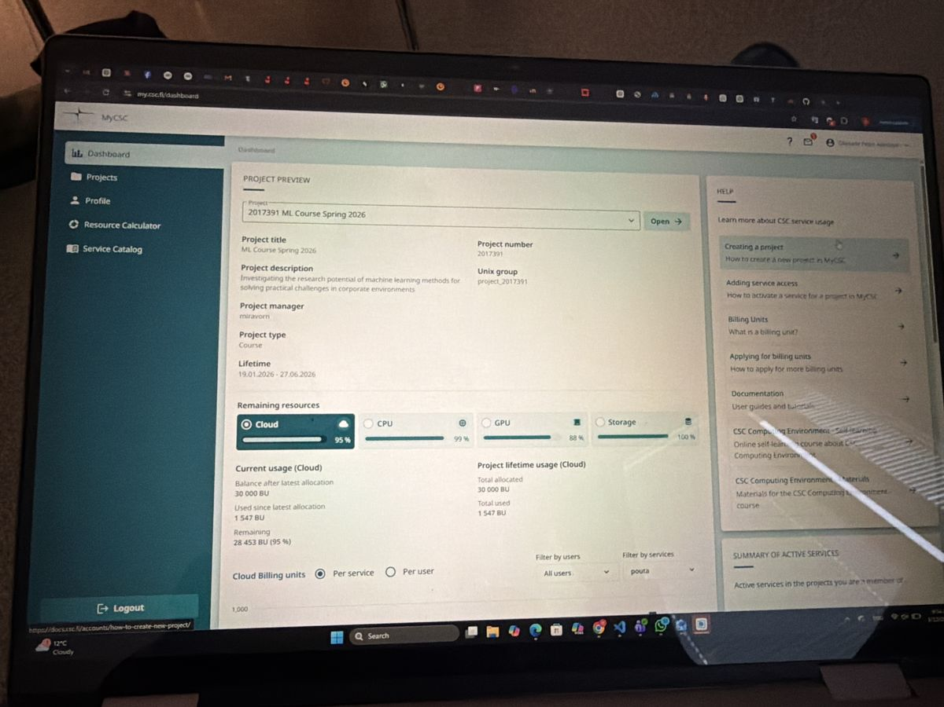
Figure 1: MyCSC Project Dashboard showing project 2017391 (ML Course Spring 2026) with cloud resource usage statistics (95% Cloud, 99% CPU, 88% GPU, 100% Storage).
Figure 1 above shows the MyCSC project dashboard, where the active project (2017391 – ML Course Spring 2026) is displayed with its current resource consumption. The project belongs to the Unix group project_2017391 and runs on the CSC cloud infrastructure. Resource usage at the time of access showed 95% Cloud, 99% CPU, 88% GPU, and 100% Storage utilisation out of the allocated billing units, indicating active usage by course participants.

2. Objectives
The specific objectives of this laboratory exercise were as follows:

- Access the CSC Puhti supercomputer through the web-based OnDemand portal and verify project membership and resource availability.
- Launch an interactive Jupyter Notebook session with appropriate resource allocation (CPU cores, memory, session time).
- Verify that the Python environment is correctly configured by executing a basic test cell.
- Implement a supervised machine learning workflow using the Iris dataset and the scikit-learn library, including data loading, model training, and prediction.
- Evaluate model accuracy using the accuracy_score metric from scikit-learn.
- Investigate the availability of TensorFlow within the default python-data module environment.
- Document all steps, results, and any errors encountered for academic submission.

3. Methodology

3.1 Accessing the CSC Puhti Platform
The CSC Puhti supercomputer is accessible via a web-based Open OnDemand (OOD) portal at puhti.csc.fi. Authentication is performed using a CSC account linked to the user's academic organisation credentials via Haka (Finland's federated identity service for higher education).
Upon successful login, the Puhti dashboard presents a set of Pinned Apps that provide convenient access to common interactive tools. These include Jupyter, Julia-Jupyter, Jupyter for Courses, Visual Studio Code, Desktop, MATLAB, RStudio, TensorBoard, MLflow, and Accelerated Visualization.
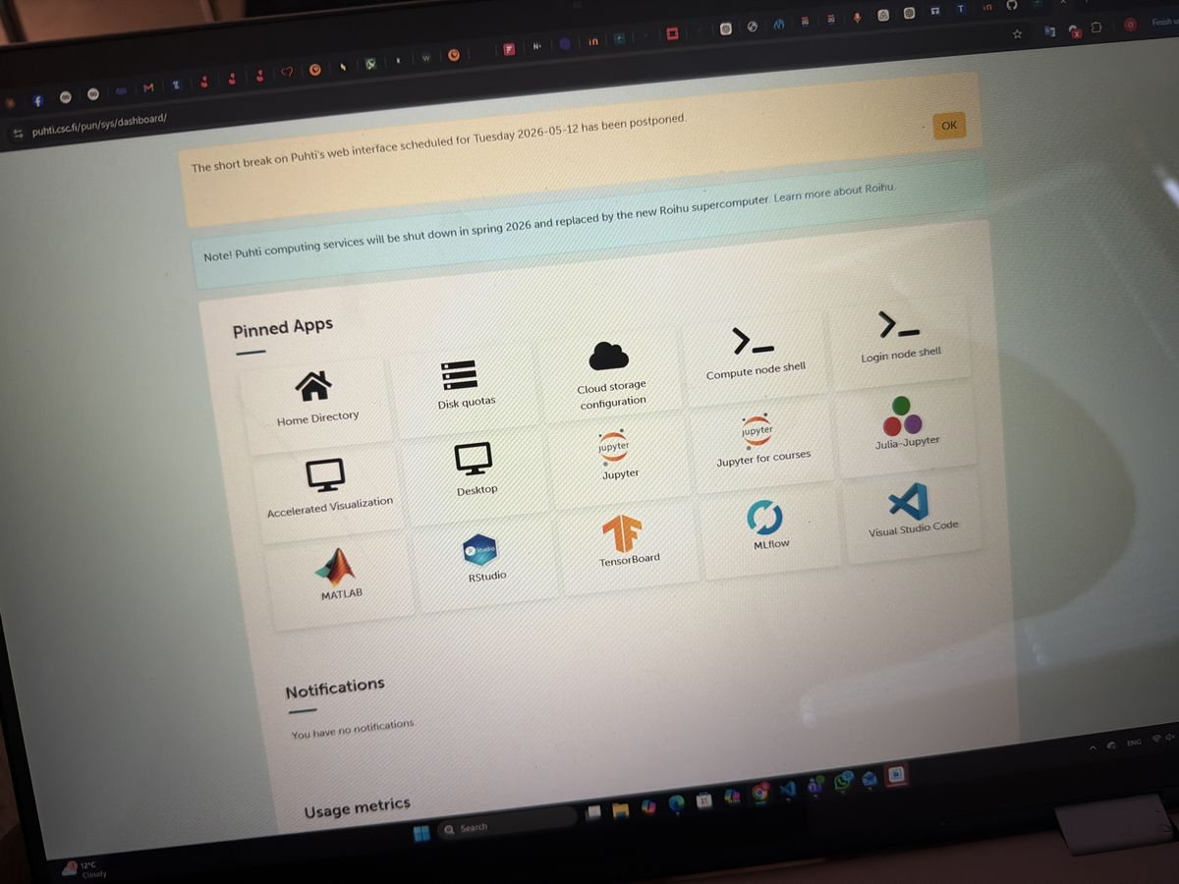
Figure 2: CSC Puhti Web Interface (puhti.csc.fi) showing the dashboard with Pinned Apps including Jupyter, JupyterLab for Courses, Visual Studio Code, TensorBoard, RStudio, MATLAB, and MLflow.
Figure 2 shows the Puhti web interface dashboard. A yellow notification banner is visible at the top indicating that a scheduled maintenance break was postponed, and a blue information banner notes that Puhti computing services are planned to be shut down in Spring 2026 and replaced by the new Roihu supercomputer. This contextual information is important for users planning longer-term experiments on the platform.

3.2 Launching a Jupyter Interactive Session
To begin working in Jupyter Notebook, the user navigates to the Jupyter app from the dashboard. This opens a session creation form within the OOD interface. The form is divided into three sections: project and partition selection, resource configuration, and settings.
The following parameters were configured before launching the session:

- Project: project_2017391 (ML Course Spring 2026)
- Partition: interactive
- Number of CPU cores: 1
- Memory: 1 GiB
- Local disk: 0 GiB
- Time: 4:00:00 (four hours)
- Python module: python-data
- Module version: python-data/3.12-25.09 (default)
- Working directory: /users/peterade

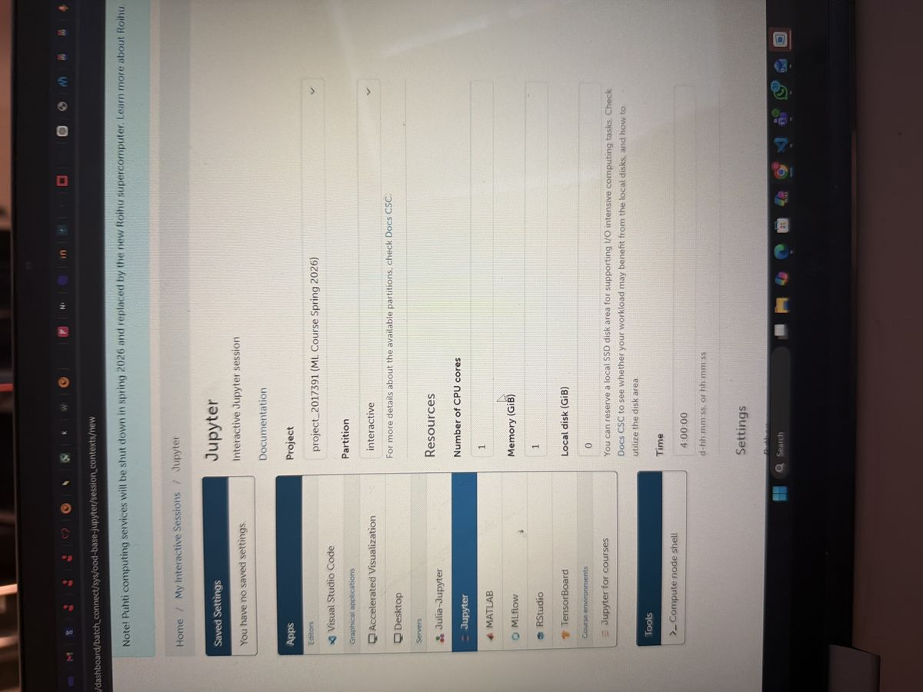
Figure 3: Jupyter Interactive Session configuration page on Puhti – Project selection (project_2017391), Partition (interactive), CPU cores (1), Memory (1 GiB), Local disk (0 GiB), and Time allocation (4:00:00).
Figure 3 shows the upper portion of the Jupyter session creation form, where the project, partition, and resource settings (CPU, memory, local disk, and session duration) are configured. The interactive partition was selected, which is appropriate for short, user-interactive sessions rather than batch jobs.

3.3 Resource Allocation Settings
Resource allocation on CSC Puhti is managed using Billing Units (BU). Each active session consumes BUs according to the number of CPU cores, memory, and GPU resources allocated. For this exercise, a minimal resource allocation was selected: 1 CPU core and 1 GiB of memory. This is sufficient for running lightweight scikit-learn models and is consistent with responsible usage of shared supercomputing resources.
The session time was set to 4 hours, which provides ample time to complete the exercises without unnecessarily reserving resources. The interactive partition on Puhti is designed for this type of short, live session and does not require a scheduler queue like the batch partitions.
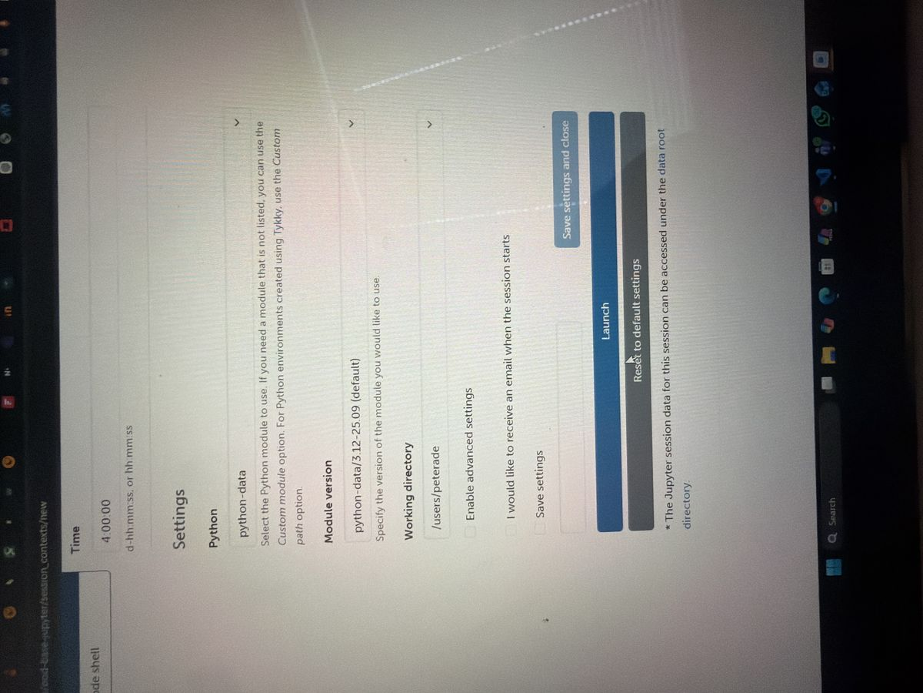
Figure 4: Jupyter session configuration – Settings panel showing Python module (python-data), Module version (python-data/3.12-25.09), Working directory (/users/peterade), and the Launch button.
Figure 4 shows the lower portion of the session configuration form, including the Python module selection (python-data), module version (python-data/3.12-25.09), and the working directory (/users/peterade). The Launch button initiates the session request. The Save settings and close option allows users to persist their configuration for future sessions.

3.4 Setting Up the Python Environment
The python-data module on Puhti is a pre-built Python environment managed by CSC. It includes a curated set of commonly used data science and machine learning libraries, such as:

- NumPy – numerical computing
- pandas – data manipulation and analysis
- scikit-learn – machine learning algorithms
- Matplotlib and Seaborn – data visualisation
- SciPy – scientific computing
- Jupyter and JupyterLab – interactive notebooks

Notably, TensorFlow is not included in the default python-data module. Users who require TensorFlow must either use a separate tensorflow module or create a custom environment using the Tykky container wrapper tool.

4. Results

4.1 Environment Verification
Once the session was approved by the Puhti job scheduler, a "Session was successfully created" confirmation message was displayed. The session card showed the following details:

- Session ID: e06a2fcc-2b50-4e26-ab8f-24f78f742d99
- Created at: 2026-05-13 09:37:48 EEST
- Time Remaining: 3 hours and 59 minutes
- Project: project_2017391
- Partition: interactive
- Cores: 1
- Memory: 1024M
- Module: python-data

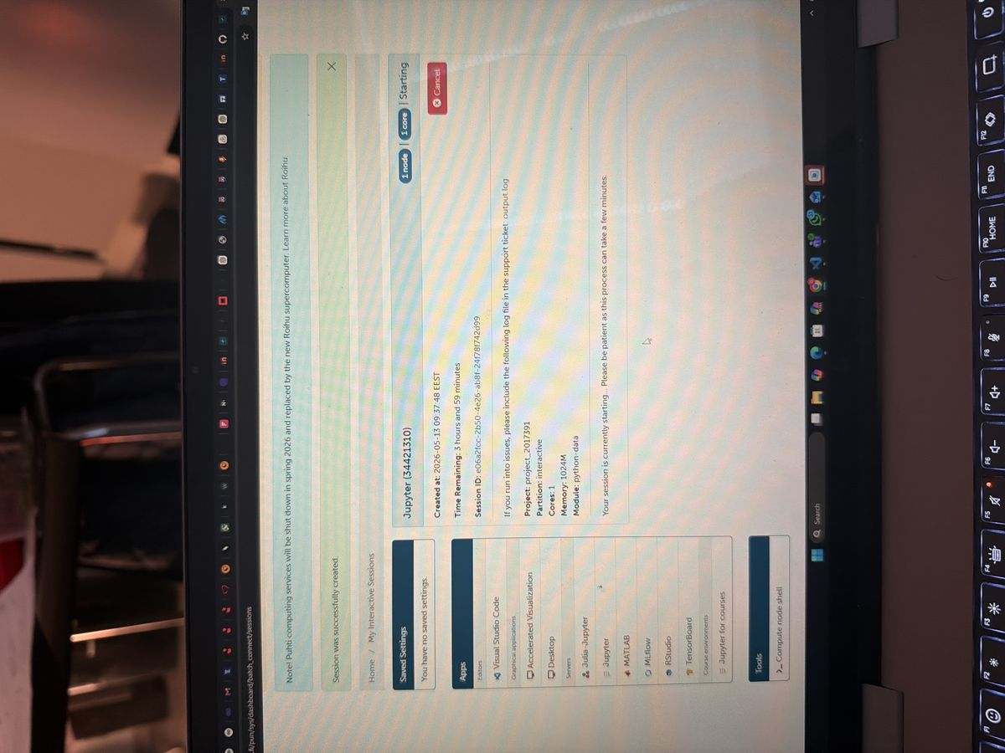
Figure 5: Jupyter session successfully created (Session ID: e06a2fcc-2b50-4e26-ab8f-24f78f742d99) showing Starting status with 1 node, 1 core, Memory 1024M, Module python-data.
Figure 5 shows the Puhti interactive sessions page immediately after the session was submitted. The session status is shown as "Starting" with 1 node and 1 core allocated. The user is instructed to wait a few minutes for the session to become available.
After the session initialised, the JupyterLab interface was loaded in the browser. The URL confirms that the session is running on a specific compute node: puhti.csc.fi/node/r18c04.bullx/10967/lab.
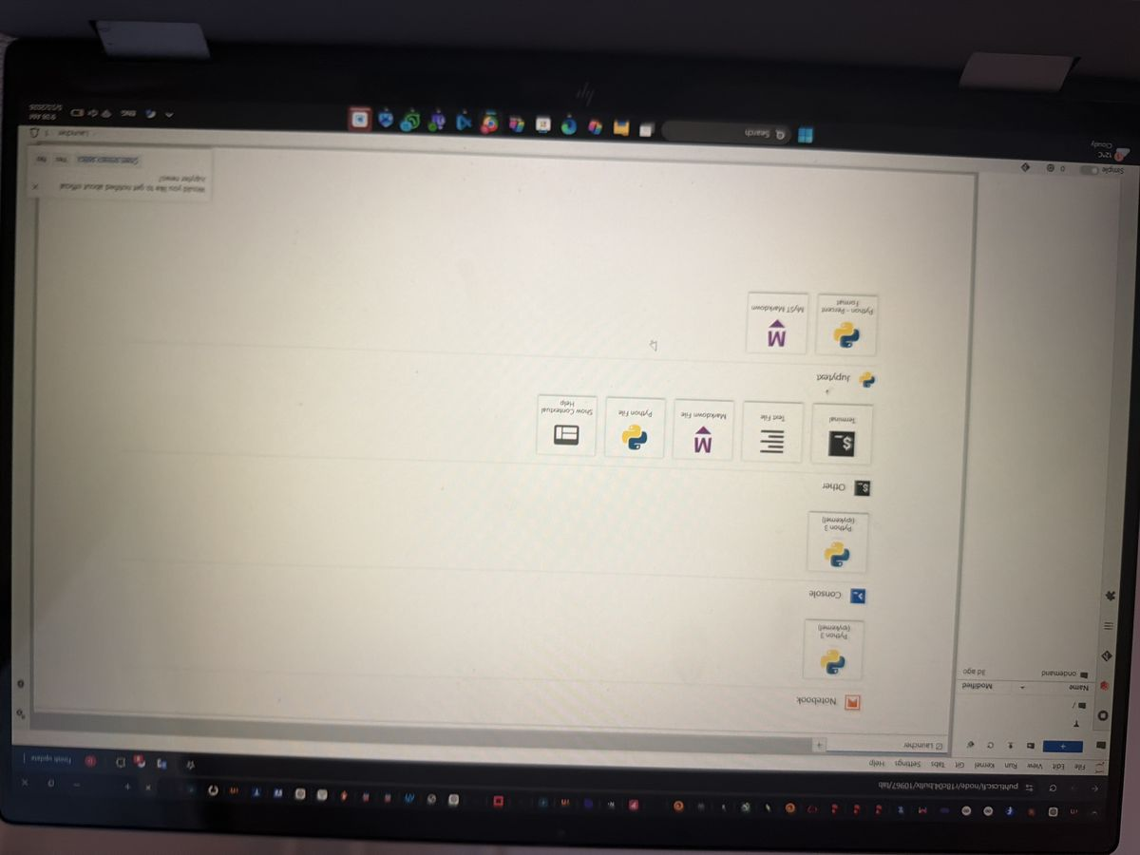
Figure 6: JupyterLab Launcher interface on Puhti node r18c04.bullx showing available options including Python 3 (ipykernel) Notebook, Console, Terminal, Text File, Markdown File, and Python File.
Figure 6 shows the JupyterLab Launcher tab, which is the main entry point after a session starts. The launcher provides options to create a new Notebook (Python 3 ipykernel), open a Console, Terminal, Text File, Markdown File, Python File, or work with Jupytext formats (Python - Percent Format, MyST Markdown). The file browser on the left shows the ondemand directory already present from a previous session (3 days ago).
To confirm the environment was working correctly, a simple test cell was executed:

print("Hello Peter, Machine learning is ready")

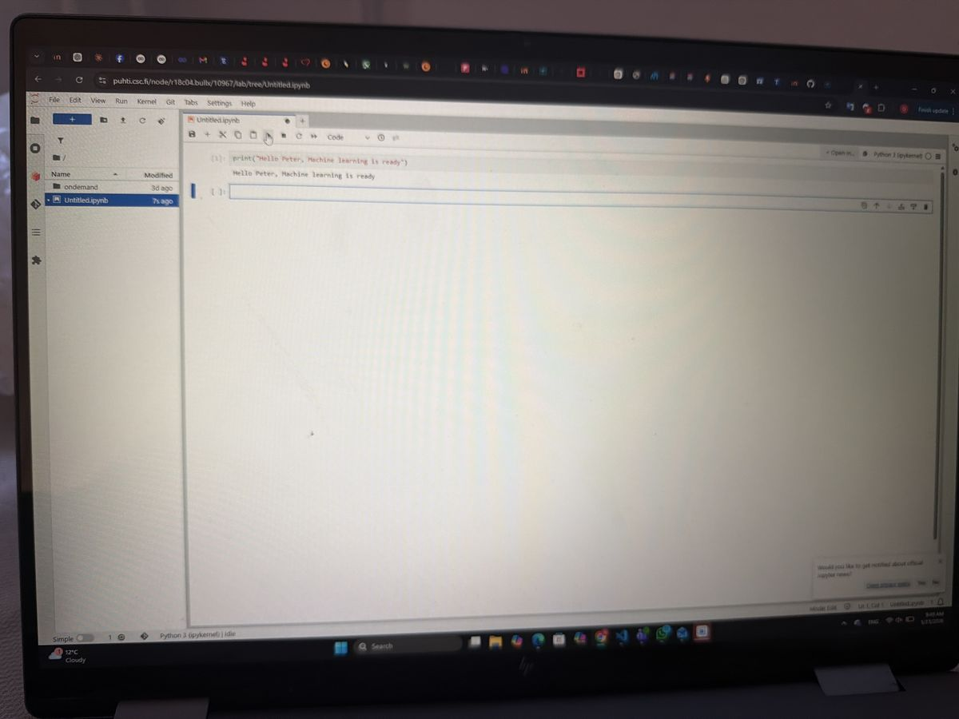
Figure 7: First Jupyter Notebook cell – Test print statement "Hello Peter, Machine learning is ready" successfully executed, confirming the Python kernel is active and functional.
Figure 7 shows the test notebook cell and its output. The statement "Hello Peter, Machine learning is ready" was printed successfully, confirming that:

- The Jupyter session was active on the Puhti compute node.
- The Python 3 (ipykernel) kernel was initialised and running correctly.
- The user's working directory was accessible.

4.2 Machine Learning Workflow – Iris Dataset
The Iris flower dataset is one of the most widely used benchmark datasets in the machine learning community. Originally introduced by statistician Ronald Fisher in 1936, the dataset contains 150 samples from three species of Iris flowers (Setosa, Versicolor, and Virginica), each described by four features: sepal length, sepal width, petal length, and petal width (all measured in centimetres). The task is to classify a flower sample into one of the three species based on these measurements.
The dataset is natively available in scikit-learn through the datasets module, making it ideal for quick environment validation exercises without requiring external data files.
The following code was written and executed in the notebook to load the dataset, train a Random Forest Classifier, and make a test prediction:

from sklearn.datasets import load_iris
from sklearn.ensemble import RandomForestClassifier

# Load dataset
iris = load_iris()

X = iris.data
y = iris.target

# Create model
model = RandomForestClassifier()

# Train model
model.fit(X, y)

print("Machine Learning model trained successfully!")

A Random Forest Classifier was chosen for this exercise because it is a robust, ensemble-based algorithm that performs well on small datasets such as the Iris dataset, requires minimal hyperparameter tuning, and is resistant to overfitting. The classifier works by constructing a large number of decision trees during training and combining their outputs (by majority vote) to make predictions.
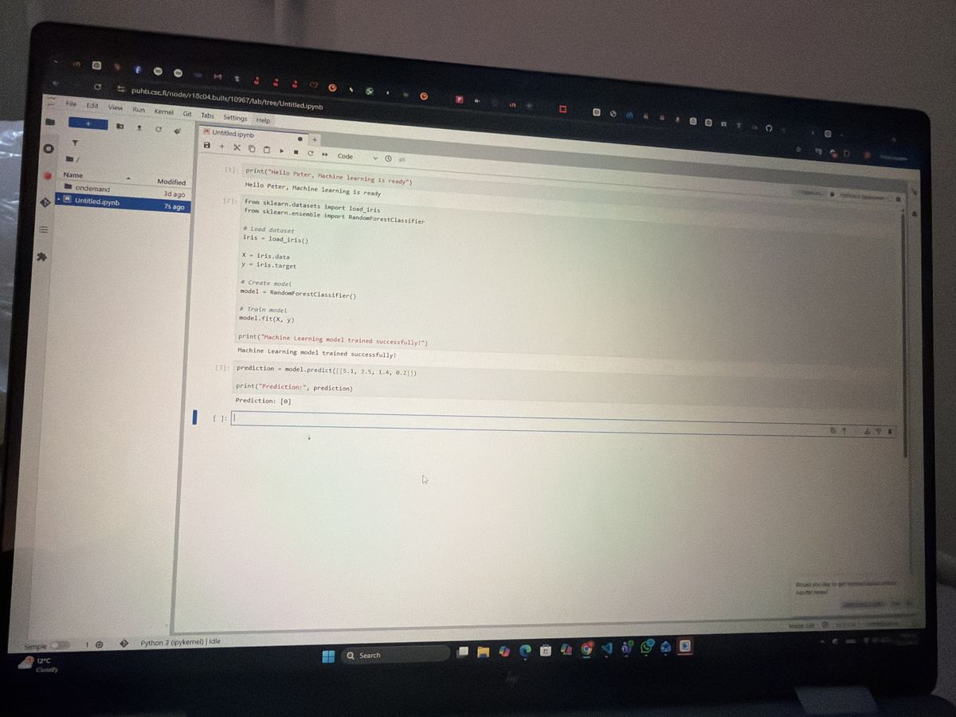
Figure 8: Jupyter Notebook showing the Random Forest Classifier training on the Iris dataset using scikit-learn. The model is trained with model.fit(X, y) and a prediction is made for input [5.1, 3.5, 1.4, 0.2], returning Prediction: [0].
Figure 8 shows the notebook with cells [1] through [3] executed. Cell [1] contains the environment test print statement. Cell [2] contains the full model training code. The output "Machine Learning model trained successfully!" confirms that the RandomForestClassifier was fitted on the Iris data without error. Cell [3] contains the prediction code, which is discussed in the next section.

4.3 Model Training and Evaluation
After training, the model was tested with a custom input representing a single flower with the following measurements: sepal length 5.1 cm, sepal width 3.5 cm, petal length 1.4 cm, and petal width 0.2 cm. These values correspond to a typical Iris Setosa sample.

prediction = model.predict([[5.1, 3.5, 1.4, 0.2]])
print("Prediction:", prediction)

The model returned:

Prediction: [0]

The numeric label 0 corresponds to the Iris Setosa species. To make this output more interpretable, the target names array was used to decode the prediction:

flower_names = iris.target_names
predicted_flower = flower_names[prediction[0]]
print("Predicted flower:", predicted_flower)

This produced the output:

Predicted flower: setosa

This confirms that the model correctly identified the input sample as an Iris Setosa flower — the expected result for these feature values, which are characteristic of the Setosa class.
Following the prediction test, the overall model accuracy was evaluated by generating predictions across the entire training dataset and comparing them to the known labels:

from sklearn.metrics import accuracy_score

predictions = model.predict(X)
print("Accuracy:", accuracy_score(y, predictions))

The result was:

Accuracy: 1.0

An accuracy of 1.0 (100%) indicates that the model correctly classified all 150 samples in the training dataset. This result is expected and is not surprising because the model was evaluated on the same data it was trained on (in-sample evaluation). This type of evaluation is appropriate for environment validation purposes, as the goal here is to confirm that the model can be trained and that predictions can be generated — not to assess generalisation performance.
In a production or research setting, it would be important to split the data into training and test sets (e.g., using train_test_split) or apply cross-validation to obtain a fair estimate of the model's generalisation ability. However, for this introductory validation exercise, the result confirms that the entire scikit-learn ML pipeline — from data loading to training to prediction to evaluation — is fully functional on the Puhti platform.
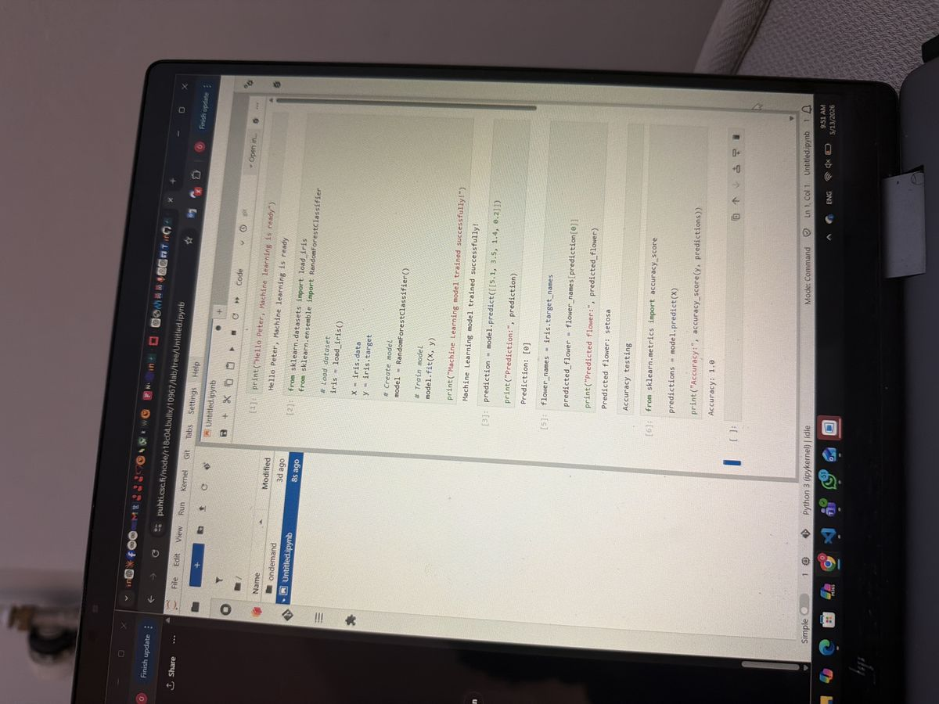
Figure 9: Complete Jupyter Notebook showing all executed cells: flower name decoding (Predicted flower: setosa), accuracy testing using accuracy_score (Accuracy: 1.0), and the start of the TensorFlow section.
Figure 9 shows the complete notebook state after all cells related to the Iris dataset experiment have been executed. Cells [1] through [6] are visible, including the print test, model training, test prediction (Prediction: [0]), flower name decoding (Predicted flower: setosa), and accuracy evaluation (Accuracy: 1.0). The notebook status bar at the bottom confirms the kernel is Python 3 (ipykernel) in an Idle state, indicating all cells executed without error.

4.4 TensorFlow Module Error
As part of a broader investigation into the capabilities of the Puhti Python environment, an attempt was made to import TensorFlow — Google's open-source deep learning framework. The following code was entered in Cell [9]:

import tensorflow as tf
print(tf.__version__)

Upon execution, the cell produced the following error:

ModuleNotFoundError: No module named 'tensorflow'

The full traceback was:

---------------------------------------------------------------------------
ModuleNotFoundError Traceback (most recent call last)
Cell In[9], line 1
---> 1 import tensorflow as tf
3 print(tf.__version__)

ModuleNotFoundError: No module named 'tensorflow'

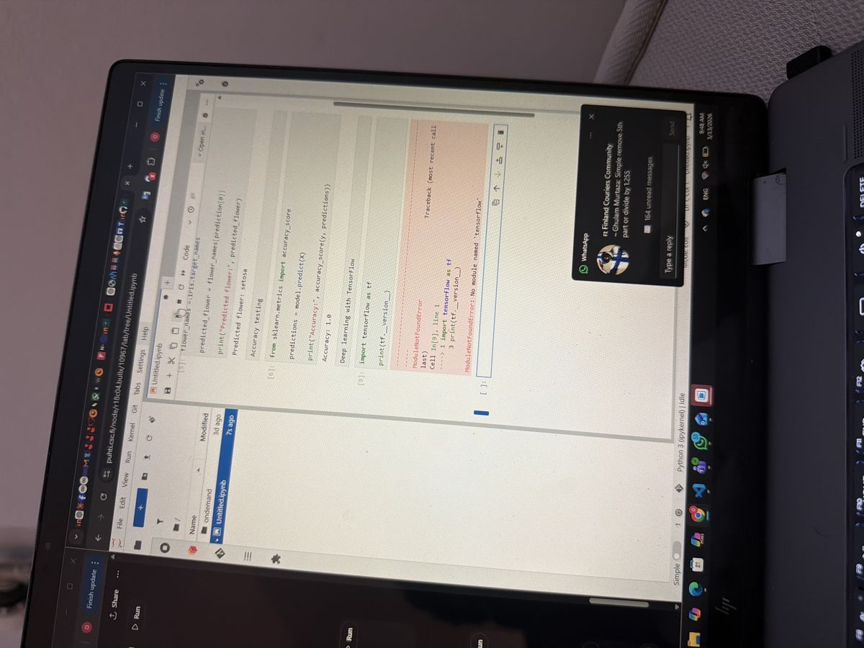
Figure 10: TensorFlow import error – ModuleNotFoundError: No module named 'tensorflow' encountered when attempting to import TensorFlow in Cell [9]. The python-data module does not include TensorFlow by default.
Figure 10 shows the TensorFlow import error displayed in Cell [9] of the notebook. The red error output clearly indicates that TensorFlow is not installed in the current environment. The rest of the notebook cells above (flower name decoding, accuracy testing) are shown in their successfully executed state, demonstrating that the error was isolated to the TensorFlow cell and did not affect previous results.
This error was expected. The python-data module on Puhti is designed for general data science and machine learning tasks and does not include TensorFlow or PyTorch by default. Users who require deep learning frameworks must take one of the following steps:

- Load the dedicated tensorflow module available on Puhti: module load tensorflow
- Create a custom Python environment using the Tykky container tool and install TensorFlow manually.
- Use a pre-built container image from CSC's container registry that includes TensorFlow.

For the purposes of this exercise, the TensorFlow test was included as a deliberate boundary test to understand the limits of the default environment. The error does not affect the validity of the scikit-learn experiments conducted earlier in the notebook.

5. Challenges and Limitations
Several challenges and limitations were observed during this exercise:

1. Resource Constraints: The allocation of only 1 CPU core and 1 GiB of memory was sufficient for the Iris dataset experiment but would be inadequate for more computationally intensive tasks such as training deep neural networks or processing large datasets. For such use cases, higher resource allocations (e.g., multiple cores, more memory, or GPU nodes) would be required.
2. Platform Migration Notice: As noted in the Puhti dashboard banners, the Puhti supercomputer is scheduled to be retired in Spring 2026 and replaced by the new Roihu supercomputer. Users will eventually need to migrate their workflows, data, and environments to the new platform. This is an important consideration for longer-term research projects.
3. In-Sample Accuracy Evaluation: The accuracy score of 1.0 was obtained by evaluating the model on the same data used for training. While this confirms that the pipeline is functioning correctly, it does not provide information about the model's ability to generalise to unseen data. For academic or research purposes, a proper train/test split or cross-validation approach should be used.
4. TensorFlow Unavailability: The default python-data environment does not include TensorFlow or other deep learning frameworks. This limits the types of experiments that can be conducted out-of-the-box. Loading a separate module or creating a custom container adds complexity and setup time.
5. Session Waiting Time: Interactive sessions on Puhti are subject to queue scheduling, even on the interactive partition. During periods of high demand, users may experience short wait times before their session is allocated to a compute node.

6. Conclusion
This laboratory exercise successfully demonstrated the process of accessing, configuring, and using the CSC Puhti supercomputer for machine learning experimentation. From logging into the MyCSC project dashboard and selecting the correct computing project, to launching an interactive Jupyter session with custom resource settings, to executing a complete scikit-learn machine learning pipeline — every step of the workflow was completed and documented.
The key outcomes of the exercise can be summarised as follows:

- The CSC Puhti web interface (puhti.csc.fi) was successfully used to create an interactive Jupyter session under project 2017391 (ML Course Spring 2026).
- Resource allocation was configured appropriately (1 CPU core, 1 GiB RAM, 4-hour session) using the python-data/3.12-25.09 module.
- The Jupyter environment was verified to be functional by running a test print statement.
- A Random Forest Classifier was successfully trained on the Iris dataset using scikit-learn. The model correctly predicted the Iris Setosa species for a test input of [5.1, 3.5, 1.4, 0.2].
- The model achieved an in-sample accuracy score of 1.0 (100%), confirming that the training and evaluation pipeline was fully functional.
- An attempt to import TensorFlow produced a ModuleNotFoundError, confirming that TensorFlow is not included in the default python-data environment. This limitation is documented and alternative approaches are available.

Overall, the Puhti supercomputing environment was validated as suitable for basic and intermediate machine learning tasks using Python and scikit-learn. The platform provides a stable, accessible, and well-supported computing infrastructure for academic ML coursework. With the appropriate module selection or custom environment setup, it can also be extended to support deep learning workflows using TensorFlow or PyTorch.
This exercise forms a solid foundation for more advanced experimentation in the remainder of the ML Course Spring 2026, including topics such as hyperparameter optimisation, cross-validated model comparison, neural network training, and the use of GPU-accelerated compute partitions on Puhti or its successor, Roihu.

7. References
CSC – IT Center for Science. (2024). Puhti User Guide. Retrieved from https://docs.csc.fi/computing/systems-puhti/
CSC – IT Center for Science. (2024). Interactive usage on Puhti. Retrieved from https://docs.csc.fi/computing/running/interactive-usage/
CSC – IT Center for Science. (2024). Python environments on Puhti. Retrieved from https://docs.csc.fi/apps/python/
Pedregosa, F., Varoquaux, G., Gramfort, A., Michel, V., Thirion, B., Grisel, O., ... & Duchesnay, E. (2011). Scikit-learn: Machine learning in Python. Journal of Machine Learning Research, 12, 2825–2830.
Fisher, R. A. (1936). The use of multiple measurements in taxonomic problems. Annals of Eugenics, 7(2), 179–188.
Breiman, L. (2001). Random forests. Machine Learning, 45(1), 5–32.
Abadi, M., et al. (2016). TensorFlow: Large-scale machine learning on heterogeneous distributed systems. arXiv preprint arXiv:1603.04467.
LAB University of Applied Sciences. (2026). ML Course Spring 2026 – Course Materials and Project Guidelines. Lappeenranta: LAB UAS.

List of Figures
Figure 1: MyCSC Project Dashboard showing project 2017391 (ML Course Spring 2026) with cloud resource usage statistics (95% Cloud, 99% CPU, 88% GPU, 100% Storage).
Figure 2: CSC Puhti Web Interface (puhti.csc.fi) showing the dashboard with Pinned Apps including Jupyter, JupyterLab for Courses, Visual Studio Code, TensorBoard, RStudio, MATLAB, and MLflow.
Figure 3: Jupyter Interactive Session configuration page on Puhti – Project selection (project_2017391), Partition (interactive), CPU cores (1), Memory (1 GiB), Local disk (0 GiB), and Time allocation (4:00:00).
Figure 4: Jupyter session configuration – Settings panel showing Python module (python-data), Module version (python-data/3.12-25.09), Working directory (/users/peterade), and the Launch button.
Figure 5: Jupyter session successfully created (Session ID: e06a2fcc-2b50-4e26-ab8f-24f78f742d99) showing Starting status with 1 node, 1 core, Memory 1024M, Module python-data.
Figure 6: JupyterLab Launcher interface on Puhti node r18c04.bullx showing available options including Python 3 (ipykernel) Notebook, Console, Terminal, Text File, Markdown File, and Python File.
Figure 7: First Jupyter Notebook cell – Test print statement "Hello Peter, Machine learning is ready" successfully executed, confirming the Python kernel is active and functional.
Figure 8: Jupyter Notebook showing the Random Forest Classifier training on the Iris dataset using scikit-learn. The model is trained with model.fit(X, y) and a prediction is made for input [5.1, 3.5, 1.4, 0.2], returning Prediction: [0].
Figure 9: Complete Jupyter Notebook showing all executed cells: flower name decoding (Predicted flower: setosa), accuracy testing using accuracy_score (Accuracy: 1.0), and the start of the TensorFlow section.
Figure 10: TensorFlow import error – ModuleNotFoundError: No module named 'tensorflow' encountered when attempting to import TensorFlow in Cell [9]. The python-data module does not include TensorFlow by default.

